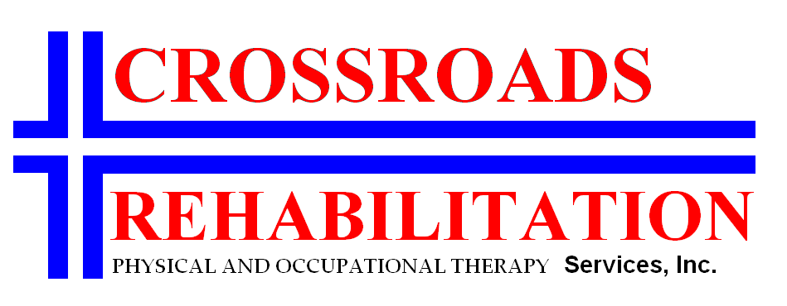

Pain Disability Index

The rating scales below are designed to measure the degree to which aspects of your life are disrupted by chronic pain. In other words, we would like to know how much pain is preventing you from doing what you would normally do or from doing it as well as you normally would. Respond to each category indicating the overall impact of pain in your life, not just when pain is at its worst. For each of the 7 categories of life activity listed, please circle the number on the scale that describes the level of disability you typically experience. A score of 0 means no disability at all, and a score of 10 signifies that all of the activities in which you would normally be involved have been totally disrupted or prevented by your pain.

Family/Home Responsibilities: This category refers to activities of the home or family. It
includes chores or duties performed around the house (e.g. yard work) and errands or favors for
other family members (e.g. driving the children to school).
No Disability 0 1 2 3 4 5 6 7 8 9 10 Worst Disability

Recreation: This disability includes hobbies, sports, and other similar leisure time activities.
No Disability 0 1 2 3 4 5 6 7 8 9 10 Worst Disability

Social Activity: This category refers to activities, which involve participation with friends and
acquaintances other than family members. It includes parties, theater, concerts, dining out, and
other social functions.
No Disability 0 1 2 3 4 5 6 7 8 9 10 Worst Disability

Occupation: This category refers to activities that are part of or directly related to one’s job.
This includes non-paying jobs as well, such as that of a housewife or volunteer.
No Disability 0 1 2 3 4 5 6 7 8 9 10 Worst Disability

Sexual Behavior: This category refers to the frequency and quality of one’s sex life.
No Disability 0 1 2 3 4 5 6 7 8 9 10 Worst Disability

Self Care: This category includes activities, which involve personal maintenance and
independent daily living (e.g. taking a shower, driving, getting dressed, etc.)
No Disability 0 1 2 3 4 5 6 7 8 9 10 Worst Disability

Life-Support Activities: This category refers to basic life supporting behaviors such as eating,
sleeping and breathing.
No Disability 0 1 2 3 4 5 6 7 8 9 10 Worst Disability

Signature__________________________________ Date ____________________

Please Print________________________________

